### UE20CS301

## Database Management System

## Lab 4 – Task I Results

Name : Renita Kurian

SRN : PES1UG20CS331

Roll No. : 13

1. Insert Records

i) Using Insert

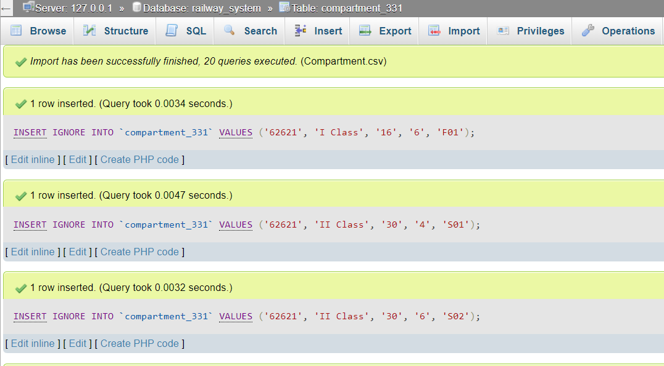

Compartment table after inserting -

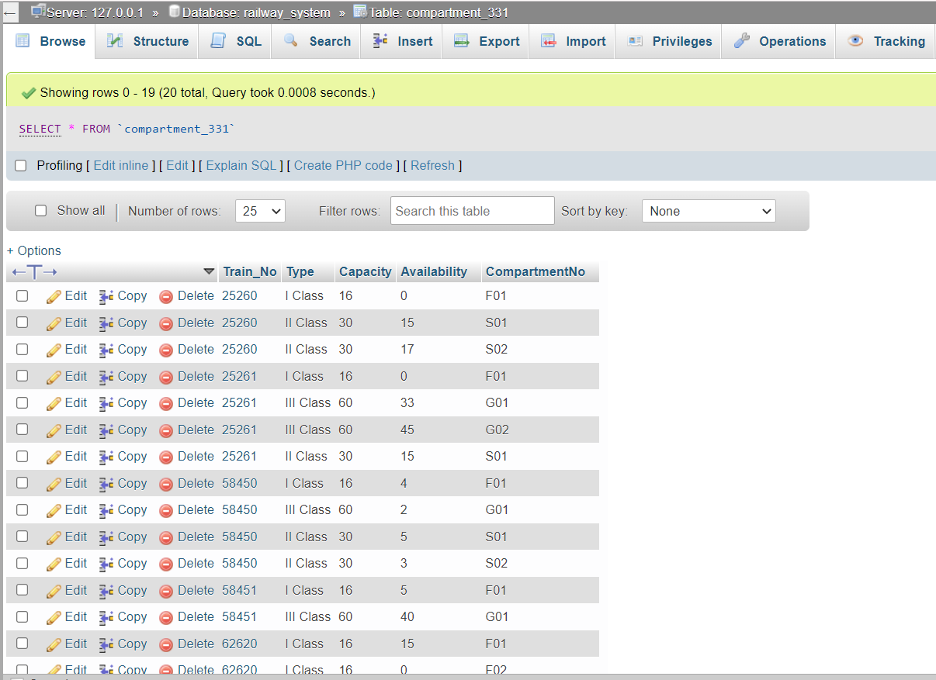

ii) Using Load data command



Ticket Table after loading -

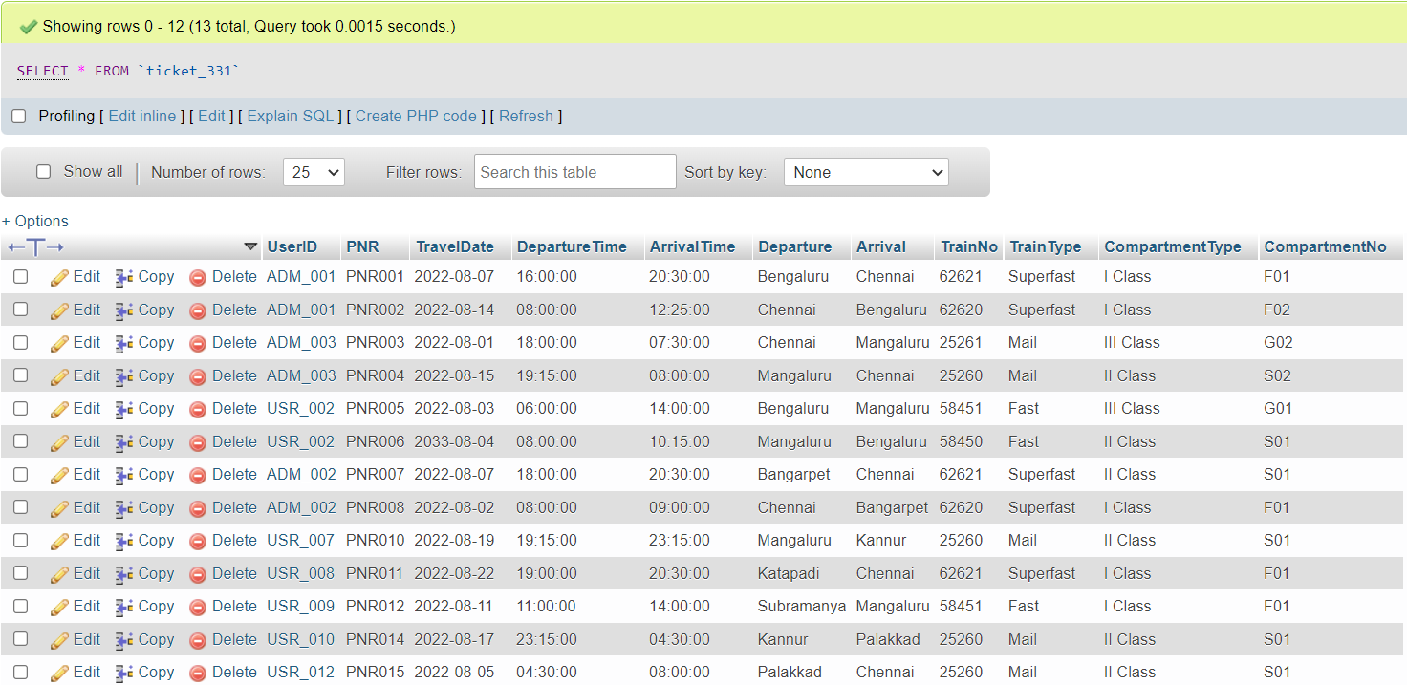

2. Calculate and update age attribute in User Table

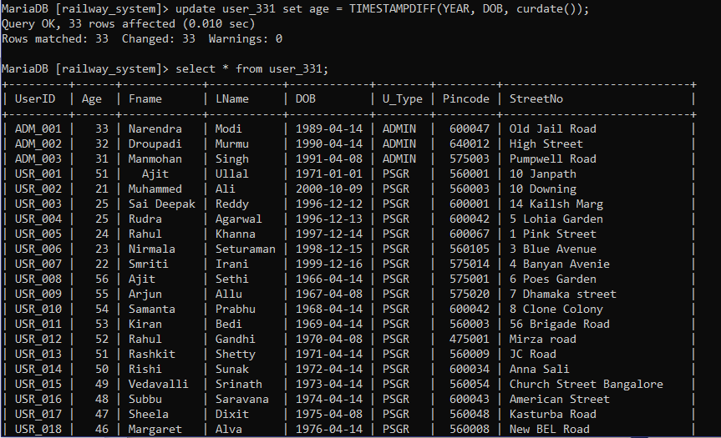

3. Routes with distance btw 70 and 150

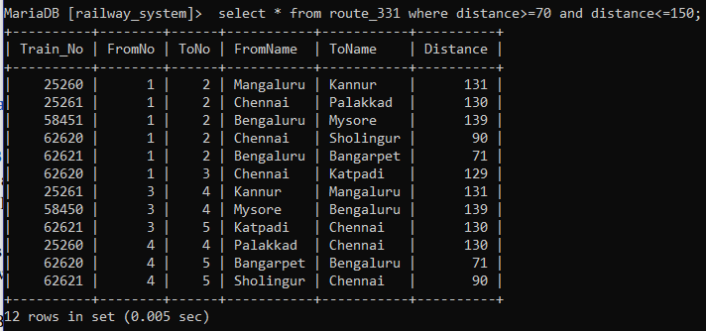

4. Chennai-Sholingur Route

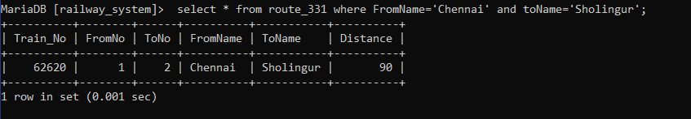

6. Chennai – Bengaluru

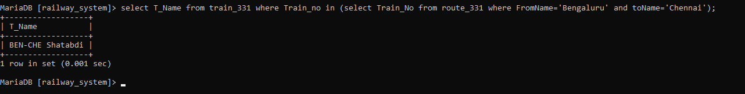

7. Chennai after 8:00

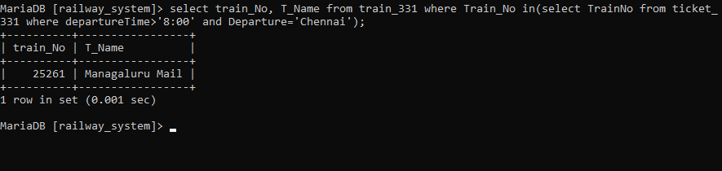

8. Users born between 1980 and 1990

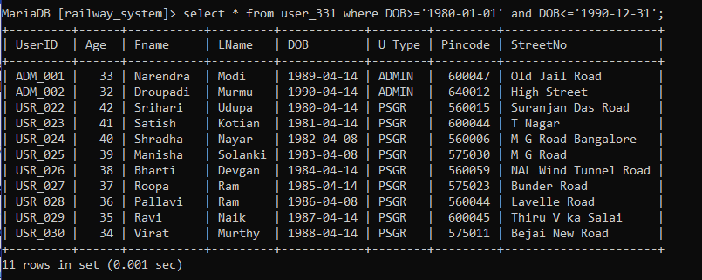

9. Users with names starting with S

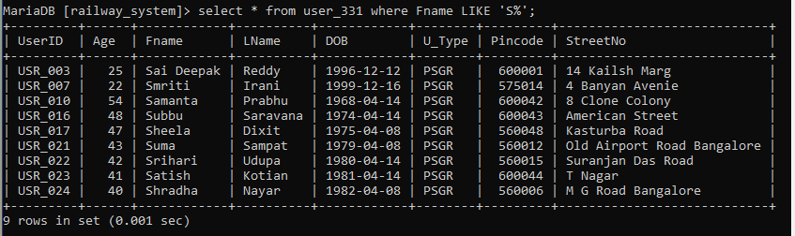

10. Availability

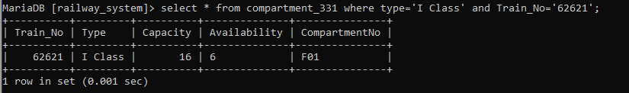

11. Union Bank

